《量子信息基础》2024.5.23随堂作业：
（2024.5.28 22:00前提交）

- Show that, in terms of the intensity fluctuations defined by $∆I\left(t\right)=I\left(t\right)-〈I\left(t\right)〉$, the second order correlation function $g^{(2)}\left(τ\right)$ can be written in the form:
$$g^{\left(2\right)}\left(τ\right)=1+\frac{〈∆I\left(t\right)∆I\left(t+τ\right)〉}{〈I\left(t\right)〉〈I\left(t+τ\right)〉}$$
Hence prove that $g^{\left(2\right)}\left(0\right)≥1$ for classical light.

$$ΔI\left(t\right)=I\left(t\right)-〈I\left(t\right)〉$$
$$I\left(t\right)=ΔI\left(t\right)+〈I\left(t\right)〉$$
$$I\left(t+τ\right)=ΔI\left(t+τ\right)+〈I\left(t+τ\right)〉$$
$$g^{\left(2\right)}\left(τ\right)=\frac{(〈∆I\left(t\right)+〈I\left(t\right)〉〉)\left(〈I\left(t+τ\right)〉+ΔI(t+τ)\right)}{〈I\left(t\right)〉〈I\left(t+τ\right)〉}=1+\frac{〈∆I\left(t\right)∆I\left(t+τ\right)〉}{〈I\left(t\right)〉〈I\left(t+τ\right)〉}$$

For classical light sources：$g^{\left(2\right)}\left(0\right)=1+\frac{〈{\left(∆I\left(t\right)\right)}^{2}〉}{{〈∆I\left(t\right)〉}^{2}}≥1$
推导正确给20分，答案正确给20分

- In the Mach-Zehnder interferometer shown below, derive the analytical relation between the output photon number $n_{3}, n_{4}$ and the input photon number $n_{1}, n_{2}$.
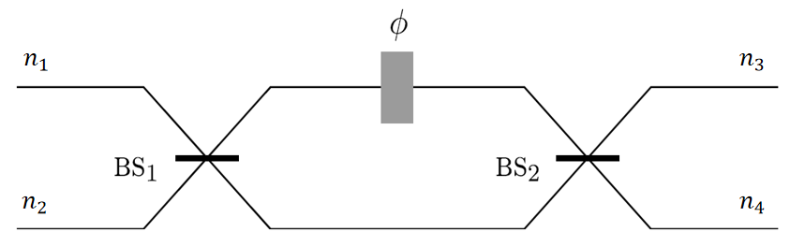

$$\left\{\begin{aligned}{\hat{b}}_{1}=\frac{1}{\sqrt{2}}({\hat{a}}_{1}+{\hat{a}}_{2}) \\ {\hat{b}}_{2}=\frac{1}{\sqrt{2}}({\hat{a}}_{1}-{\hat{a}}_{2})\end{aligned}\right. , ∴\left({{\hat{b}}_{1} \atop {\hat{b}}_{2}}\right)=\frac{1}{\sqrt{2}}\left(\begin{matrix}1 & 1 \\ 1 & -1\end{matrix}\right)\left({{\hat{a}}_{1} \atop {\hat{a}}_{2}}\right)$$

$$\left\{\begin{aligned}{\hat{b'}}_{1}={\hat{b}}_{1}·e^{iϕ} \\ {\hat{b'}}_{2}={\hat{b}}_{2}\end{aligned}\right. , ∴\left({{\hat{b}'}_{1} \atop {\hat{b}'}_{2}}\right)=\left(\begin{matrix}e^{iϕ} & 0 \\ 0 & 1\end{matrix}\right)\left({{\hat{b}}_{1} \atop {\hat{b}}_{2}}\right)$$

$$\left\{\begin{aligned}\hat{c_{1}}=\frac{1}{\sqrt{2}}({\hat{b'}}_{1}+{\hat{b'}}_{2}) \\ \hat{c_{2}}=\frac{1}{\sqrt{2}}({\hat{b^{'}}}_{1}-{\hat{b'}}_{2})\end{aligned}\right. , ∴\left({{\hat{c}}_{1} \atop {\hat{c}}_{2}}\right)=\frac{1}{\sqrt{2}}\left(\begin{matrix}1 & 1 \\ 1 & -1\end{matrix}\right)\left({{\hat{b}'}_{1} \atop {\hat{b}'}_{2}}\right)$$

$$∴\left({{\hat{c}}_{1} \atop {\hat{c}}_{2}}\right)=\frac{1}{2}\left(\begin{matrix}e^{iϕ}+1 & e^{iϕ}-1 \\ e^{iϕ}-1 & e^{iϕ}+1\end{matrix}\right)\left({{\hat{a}}_{1} \atop {\hat{a}}_{2}}\right)$$
$$\left\{\begin{aligned}n_{3}={{\hat{c}}_{1}}^{+}{\hat{c}}_{1} \\ n_{4}={{\hat{c}}_{2}}^{+}{\hat{c}}_{2}\end{aligned}\right.$$
$$∴n_{3}=\frac{1}{2}\left[{\hat{a}}_{1}\left(e^{-iϕ}+1\right)+{\hat{a}}_{2}\left(e^{-iϕ}-1\right)\right]·\frac{1}{2}\left[{\hat{a}}_{1}\left(e^{iϕ}+1\right)+{\hat{a}}_{2}\left(e^{iϕ}-1\right)\right]=\frac{1}{2}n_{1}\left(1+cosϕ\right)+\frac{1}{2}n_{2}\left(1-cosϕ\right)$$
For the same reason, $n_{4}=\frac{1}{2}n_{1}\left(1-cosϕ\right)+\frac{1}{2}n_{2}\left(1+cosϕ\right)$
三个中间步骤推导正确给40分，答案正确给20分

